Adding content to the Press Page

Overview:

To access the Press page html go to Settings> Edit Theme

Click on /press (in the list of pages) and it will automatically open the HTML editor for the Press Page (So far, I’m sure you know all of this already)

Styles are first, including a style with a GINORMOUS url. That whale is actually how the Avenir font gets onto our site! You can ignore it entirely, but you’ll have to scroll down past it to get to the rest of the theme styles and the real HTML structure of the site.

Alternately, you can search for <!-- CONTENT --> to take you right to the content. ( I usually do)

The content of the press page is set up in three vertical columns. The content stacks from top to bottom in the order it is written. For example

If the HTML is written in this order:

Item one

Item two

Item three

Then item one will be on top, item three on the bottom, and item two in the middle. Pretty simple so far.

The COLUMNS are <div> elements with classes of

<div class="column1of3">

<div class="column2of3">

and

<div class="column3of3">

Inside each column div id a ul (unordered list) tag enclosing a bunch of <li> (list item) elements

These <li>s are what you will be most concerned with.

Here is an example (highlighted in grey and then typed out below):

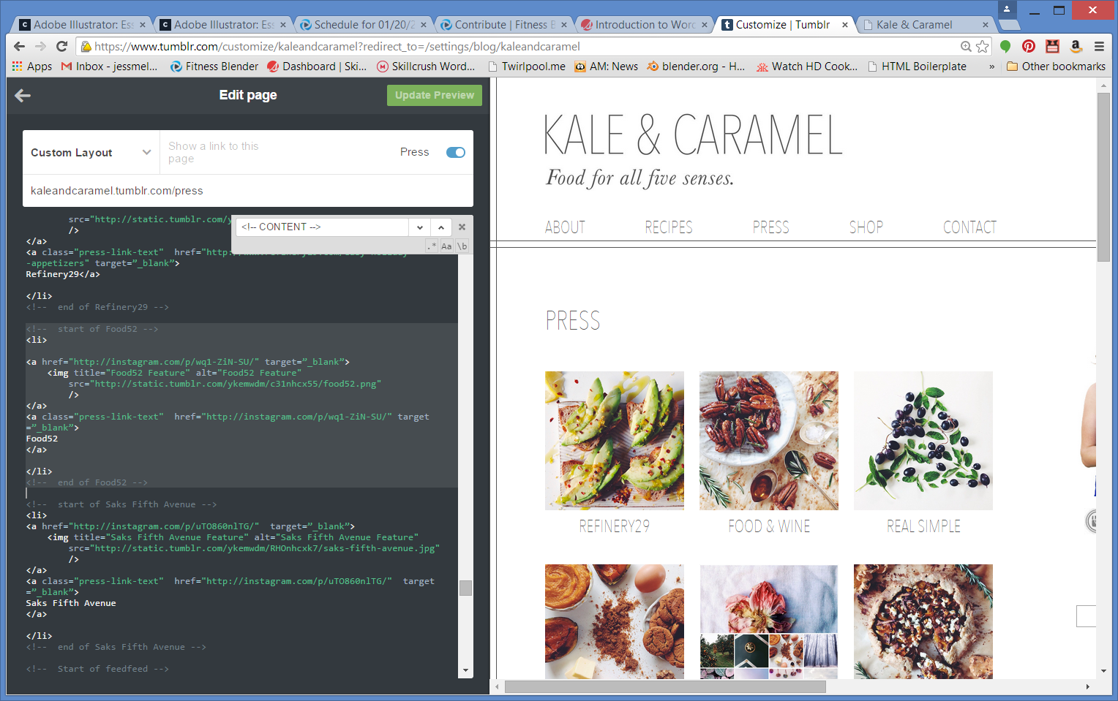

<!-- start of Food52 *--> This is a comment that keeps us organized. It has no effect on the site, but is crucial for organization, especially when more than one person is working on a site*

<li> *This tells us that a new List Item is beginning*

<a href="http://instagram.com/p/wq1-ZiN-SU/" target=”_blank*”> Inside the LI is a link that will take a user to the URL http://instagram.com/p...etc. when they click. Target=_blank means it will open in a new window/tab (depending on the user setting)*

<img title="Food52 Feature" alt="Food52 Feature" *The link is made up of an image*, don’t leave alt and title blank because they are accessibility features (like if a blind person is using a descriptive device) and that’s just bad juju and bad coding!

src=http://static.tumblr.com/ykemwdm/c31nhcx55/food52.png

/> *This is the link that is the source of the image*

</a>

<a class="press-link-text" href="http://instagram.com/p/wq1-ZiN-SU/" target=”_blank*”> Next comes a second link to the same URL*

Food52 *This link is the text link*

</a>

</li> *close the list item*

<!-- end of Food52 --> *Comment that that’s the end of this press piece, again, only for organizational purposes.*

So here’s what you do to add a new press piece:

Step zero: A) Go to this link: <https://www.tumblr.com/themes/upload_static_file>

B) Upload your new image for the new press piece

C) Copy the link that it generates – this is where your image lives on the web!

Step one: Copy one of the list items from the opening <!—comment --> to the closing <!—comment --> (everything as shown above) and paste it in the desired column (more on which column to choose below)

Step two : Change these eight elements to the new press piece’s info (red: name of new piece, orange: link to the new press piece, and blue: url for image (as uploaded via tumblr static file site from Step Zero!)):

<!-- start of **Food52** -->

<li>

<a href="**http://instagram.com/p/wq1-ZiN-SU/**" target=”_blank”>

<img title="**Food52** Feature" alt="**Food52** Feature"

src="**http://static.tumblr.com/ykemwdm/c31nhcx55/food52.png**"

/>

</a>

<a class="press-link-text" href="**http://instagram.com/p/wq1-ZiN-SU/**" target=”_blank”>

**Food52**

</a>

</li>

<!-- end of **Food52** -->

For Example:

<!-- start of **Sweet New Press Piece** -->

<li>

<a href="**http://instagram.com/SWEET-NEW-PRESS-link**" target=”_blank”>

<img title=" **Sweet New Press Piece** Feature" alt=" **Sweet New Press Piece** Feature"

src="**http://static.tumblr.com/abunchofrandomnumbers/somemorecharacters/sweet-new-press.png**"

/>

</a>

<a class="press-link-text" href=" **http://instagram.com/ SWEET-NEW-PRESS-link** " target=”_blank”>

**Sweet New Press Piece** </a>

</li>

<!-- end of **Sweet New Press Piece** -->

TA DA! Your new nugget of press is all set!

__________________________________________

Now let’s talk about **placement**!

If I simply drop my new press nugget into the top of column 1 I will go from this:

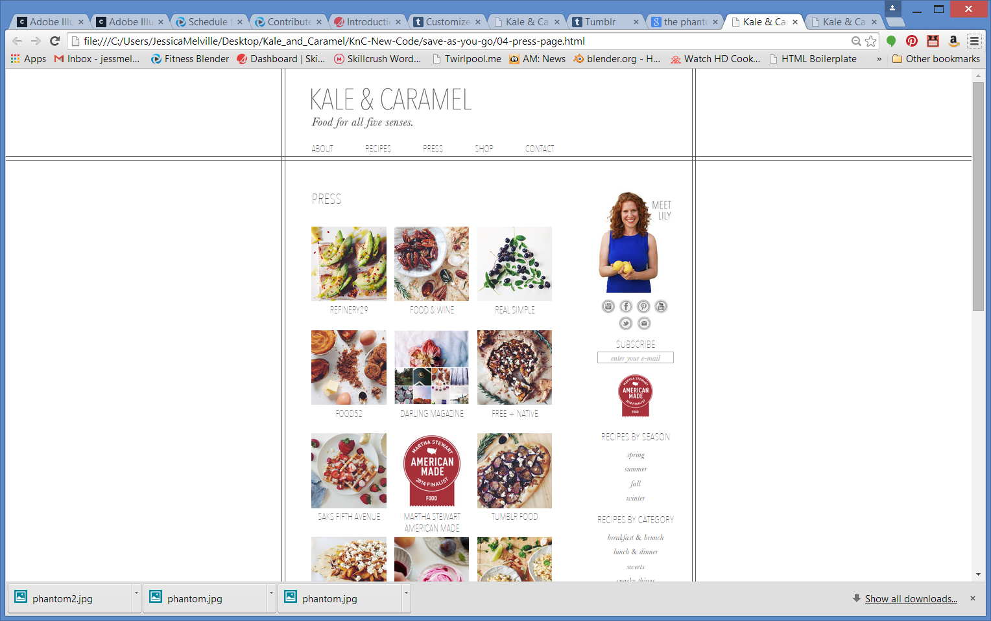

To this:

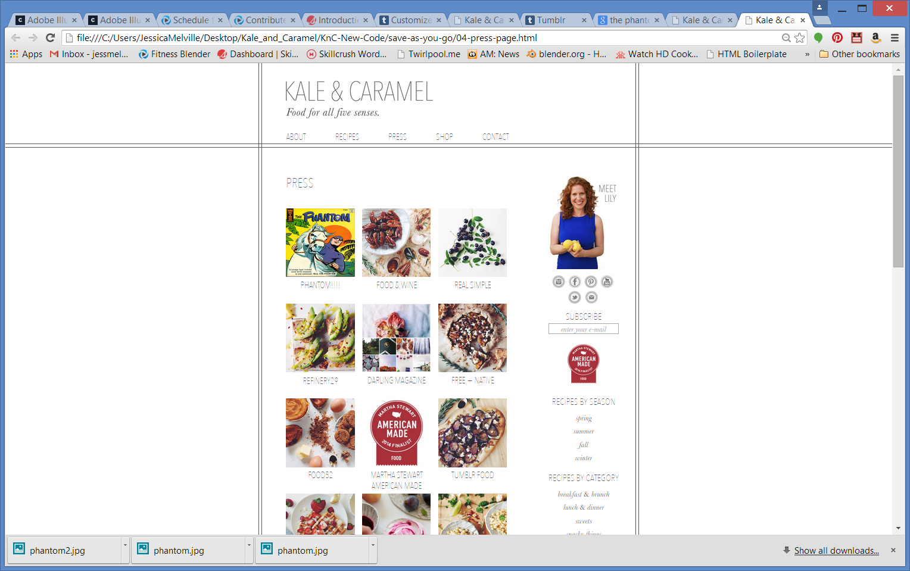

Where the whole first column just slides down.

But chances are that you probably don’t want that. You probably want Refinery to move to the spot that Food & Wine was in and Real Simple to move down to the next row.

Well, it gets a tiny bit dicey because the HTML is like “Row?? What’s a row?” It’s not the sharpest knife in the block and, pitifully, it only knows columns!

My workaround is thus:

I know that I want A) Phantom to end up in a column above Real Simple and that I want B) that column to be the leftmost column

So first I drop my new press nugget in the same column as Real Simple, right about Real Simple (or create it in that column in the first place). In this case, Real Simple is the top nugget in “column3of3” (tip: ctrl+F or mac equivalent to search for “real simple” find it fast). I drop in my new press nugget above the Real Simple nugget.

IMPORTANT: Make sure it is between the <ul> tag and the <!-- start of Real Simple --> comment, NOT ABOVE THE <ul> tag, For the love of Pete!!!

Here’s where is would be if I left it this way:

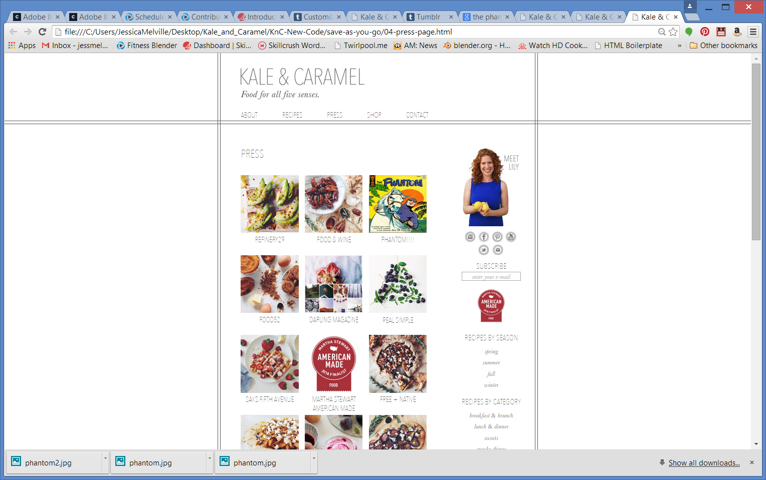

But I won’t. Instead, I will move the entire contents of column 3 into column 1, column 1 into column 2 , and column 2 into column 3!

For real. I cut everything **inside** of, but **not** including

<div class="column3of3">

to

</div> <!-- End of column 3 -->

So you will copy/cut <ul> all your nuggets </ul> , a big chunk of HTML, and move it into column1of3

And then do the same for the next two columns.

So basically, you can think of the <div> s with the names column1of3, column2of3, and column3of3 as the columns in the game connect 4

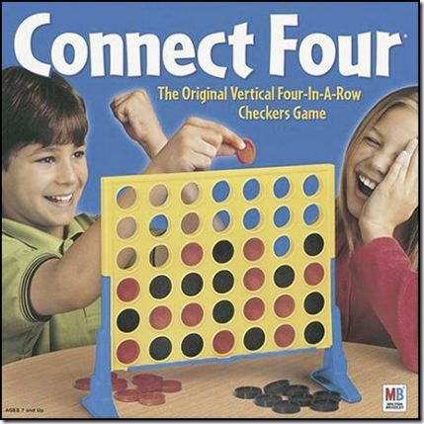,

or like big solid pipes that don’t move. And the unordered list <ul> elements and all the <li> nuggets of content that the <ul> tags wrap around are the checkers in Connect 4 or whatever it is you stack inside pipes (hmm… that metaphor is lacking, let’s just stick with connect 4. The <ul> </ul> tags wrap around the press items as if you had a microthin sleeve around your checkers and could take them all out at once and move them to another column. Okay that’s either really confusing or really helpful. You’ll have to let me know lol!

Another thing to note is that if you are adding more than one press item, you will want to figure out where you want them to go and where you want the new items to “land”. If you are adding three at once to the top, you can skip the whole column dance entirely! Just remember to think of the columns as stationary and the stacks of content as stuck together like pearls on a string.

So I get all my <ul>s situated in their new <div> column homes, and Voila! It appears as if I’ve just slipped in a new press piece and everything shifted seamlessly. It’s beautiful! Then I treat myself to a tiny pie and call it a good day. (Do you have any recipes for tiny pies???)

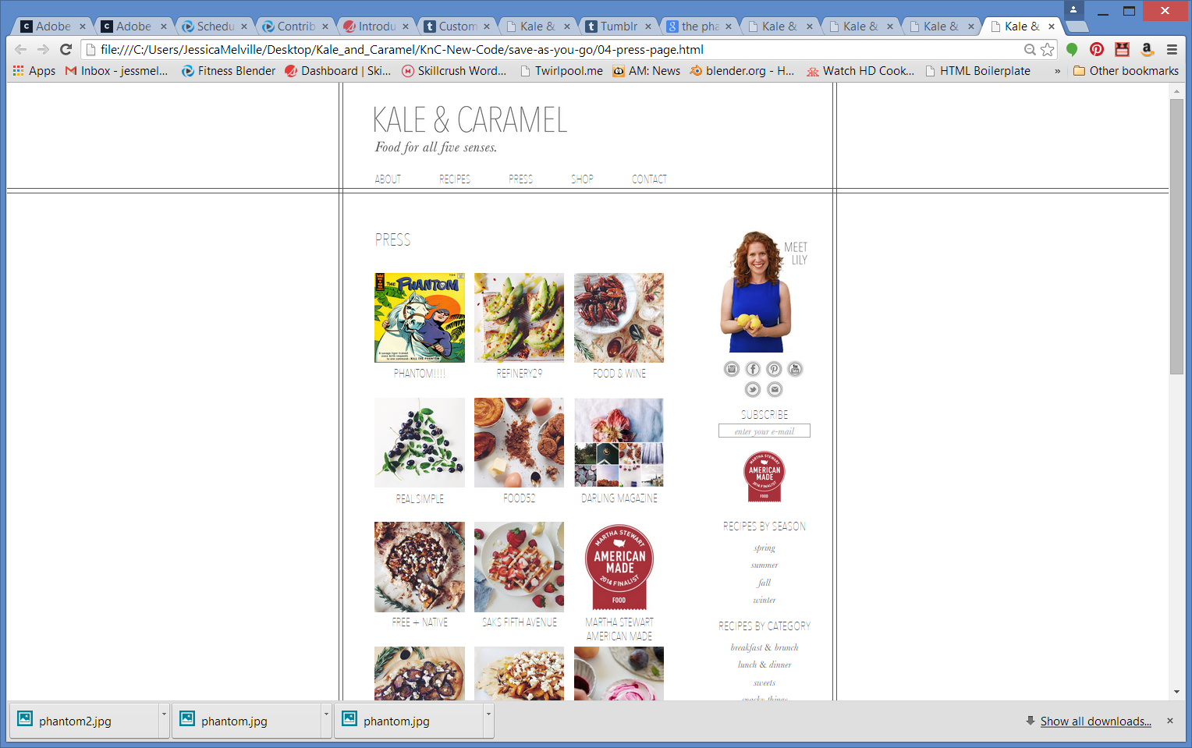

Please try this out and see if it makes sense to you or if you need me to clarify further/better/in another way/over the phone/with better metaphors.

Have a fantastic evening!

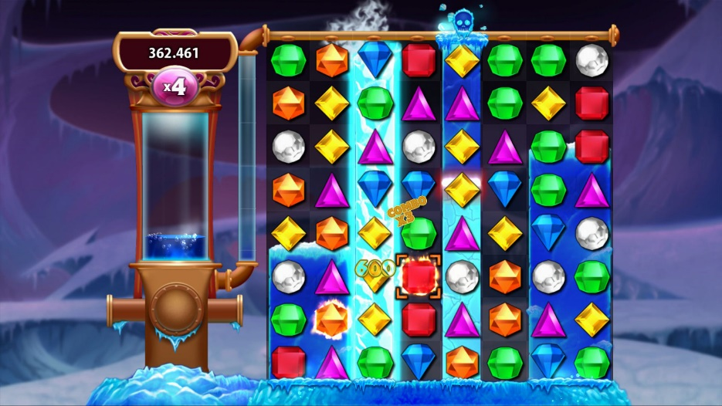

BEJEWLED!

I think it’s like Bejeweled!

Is it like Bejeweled??